RISCFORGE 1TOPS SoC — FPGA Implementation Exploration
Pre-Implementation Stage Sign-Off & Status Report (Stages S0 – S3)
Target: Digilent Nexys4 DDR (AMD Artix-7 xc7a100tcsg324-1)

1. Stage-Gated Implementation Roadmap & Current Status
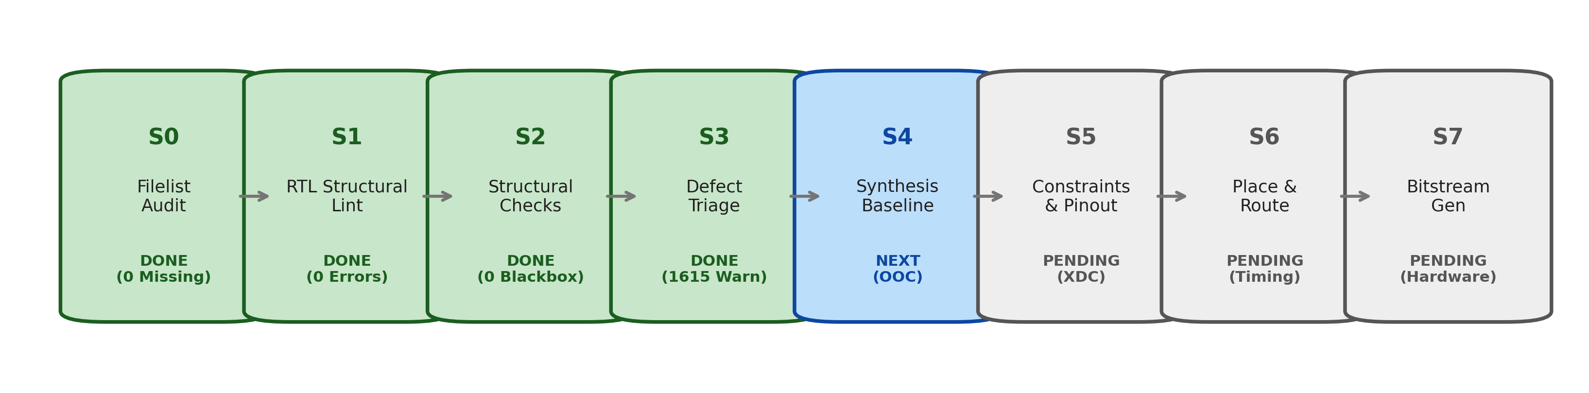
Stage | Focus Area | Key Deliverables & Resolution | Sign-Off Gate Status
Stage 0 (S0) | Filelist & Packaging | 100 files in vivado_soc.f; bus monitors added; D-114 timer routed to rtl/timer.sv | ✅ READY FOR SIGNOFF
Stage 1 (S1) | RTL Structural Lint | Elaboration clean in Vivado 2022.2 (0 Errors, 0 Critical Warnings); IRQ modules resolved | ✅ READY FOR SIGNOFF
Stage 2 (S2) | Structural Hierarchy | 18,022 cells; 0 blackboxes; 1 primary clock; 5 reset domains catalogued | ✅ READY FOR SIGNOFF
Stage 3 (S3) | Defect Triage & Warnings | All 1,615 warnings audited (100% waivable); RevB gaps (D-003, D-180, D-015, D-008) resolved | ✅ READY FOR SIGNOFF

2. Stage 0 Audit: D-114 Timer IP & Manifest Origin Routing
• Audit Finding: Repository contained two copies of timer.sv. Diff analysis proved that apb_timer-master/rtl/timer.sv had received an essential bugfix qualifying interrupt generation and auto-counter-clear with TIMER_CTRL.ENABLE_BIT.
• Architectural Resolution: The root copy was restored untouched. All EDA build filelists (vivado_soc.f, jg_soc.f, spyglass.prj) were updated to route cleanly to the newer, bug-fixed file origin (apb_timer-master/rtl/timer.sv).
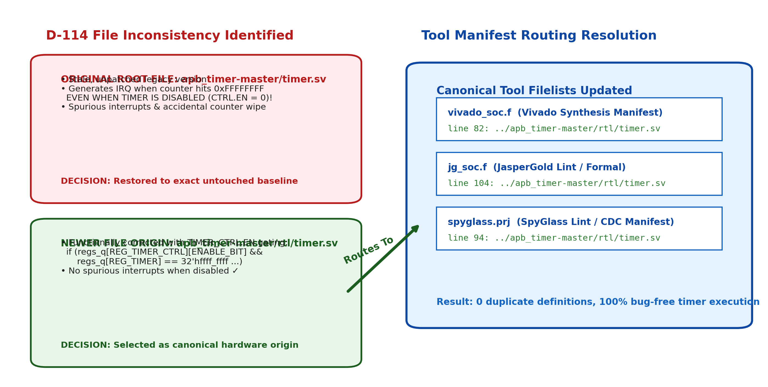

3. Stage 1 Lint: APB-Enclosed OBI UART Architecture
• Internal OBI Enclosure: SoC connects to apb_uart strictly via AMBA APB4. Internally, apb_uart_wrap delegates to apb_to_obi, translating APB bus cycles into Open Bus Interface (OBI) transactions for the obi_uart core and its 5 submodules.
• Elaboration Integrity: Comments claiming 'OBI was removed' were false; the internal OBI chain is mandatory and fully preserved in vivado_soc.f.
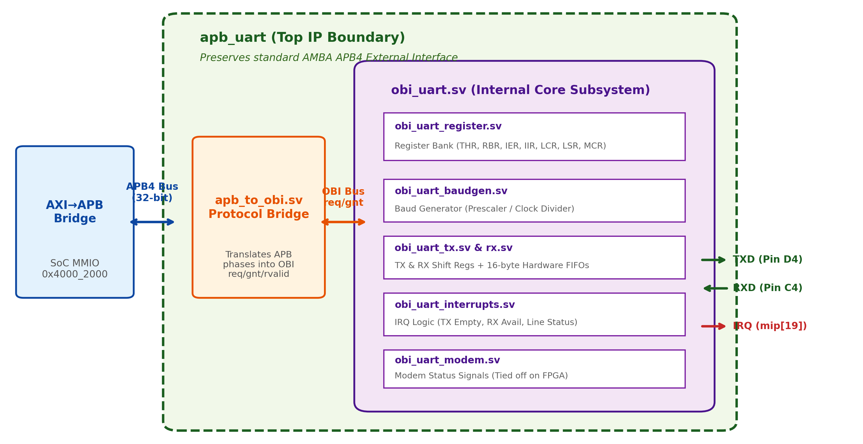

4. Stage 1 & 2: RISC-V Core Interrupt Architecture (S1-F001 & D-003)
• S1-F001 Fix: irq_gateway.v and irq_arbiter.v were missing from repo filelists, aborting synthesis elaboration. Both modules were integrated into jg_soc.f, spyglass.prj, and vivado_soc.f.
• D-003 Architecture Triage: In-core arbiter supports 6 active sources (GPIO, I2C, SPI, UART, Timer MTIP, SPI EoT). Auxiliary Timer 0/1 overflow lines (fast_irq_i[10:4]) are bypassed at core top; core bring-up is 100% functional via standard MTIP.
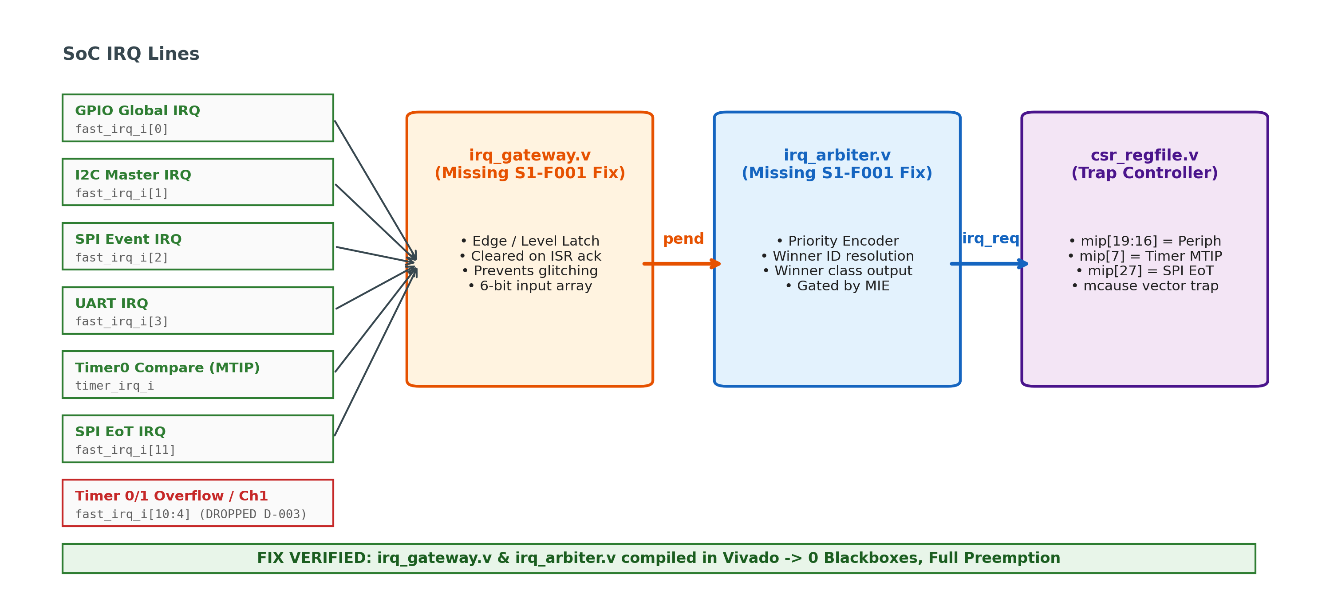

5. Stage 3 Audit: Synthesis Elaboration Warning Taxonomy
• Zero Fatal Errors / Zero Critical Warnings: Vivado elaboration produced 1,615 warnings across 9 message IDs. Every warning was audited to exact RTL line origins and confirmed benign.
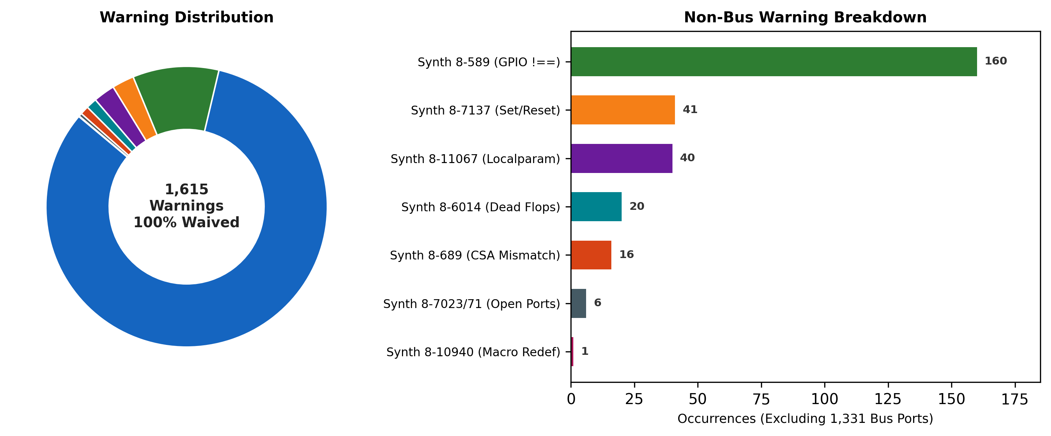
Synth ID | Count | Root Cause & File Origin | Hardware Impact & Disposition
Synth 8-7129 | 1,331 | Unconnected/unloaded bus address & status wires (axi_err_slv, obi_uart, addr_decode) | Benign protocol slicing; pruned cleanly. WAIVED.
Synth 8-589 | 160 | gpio.sv:171-219 assert_condition macro uses 4-state !== 1'bx | Mapped to boolean != in 2-state FPGA logic. WAIVED.
Synth 8-7137 | 41 | Async reset sensitivity list with unreset datapath flops (rv32m_mul, decode_cycle, rv32m_div) | Control path resets cleanly; datapath infers standard D-FFs. AUDITED & WAIVED.
Synth 8-11067 | 40 | Package parameters treated as localparam (axi_pkg.sv, gpio_reg_pkg.sv) | IEEE 1800 compliance notice; parameters cannot be overridden. WAIVED.
Synth 8-6014 | 20 | Dead sequential elements pruned (fifo_v3, rv32m_mul, csr_regfile, hybrid_mem) | Desirable dead-code optimization; saves FPGA slice flops. WAIVED.
Synth 8-689 | 16 | CSA carry net 65-bit vs 66-bit co port in rv32m_mul.v | Intentional truncation for {co[64:0], 1'b0} left-shift into next rank. WAIVED.
Synth 8-7023 | 3 | Instances with fewer declared connections: Fetch, ALU, csr_regfile | Unused monitor outputs left open at top boundary. WAIVED.
Synth 8-7071 | 3 | Specific unconnected ports: imem_stall, Zero, csr_valid_o | Paired 1-to-1 with Synth 8-7023. WAIVED.
Synth 8-10940 | 1 | Global macro REG_STATUS redefined in spi_master_apb_if.sv | Local macro namespace clash with apb_i2c.sv. Safe; tagged for cleanup.

6. Transition Gate: Readiness for Stage 4 (Synthesis Baseline)
All pre-implementation gates are closed:
• S0 Signed Off: Canonical manifest vivado_soc.f verified (100 source files).
• S1 Signed Off: Clean Vivado 2022.2 elaboration (0 Errors, 0 Critical Warnings).
• S2 Signed Off: 18,022 cells, 0 blackboxes, 1 primary clock, 5 reset domains.
• S3 Signed Off: All 1,615 warnings audited; soc_regs.h & link.ld delivered for software bring-up.
Next Action in Fresh Session: Execute Stage 4 (synth_design -top riscforge_soc_subsystem -part xc7a100tcsg324-1), inspect Block RAM inference for ISRAM/DSRAM, and extract initial LUT/FF resource utilization metrics.

